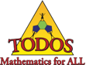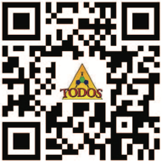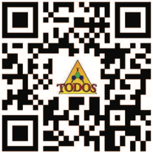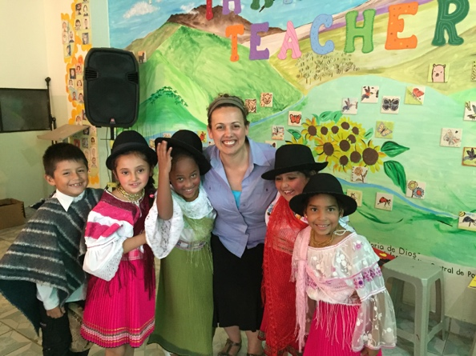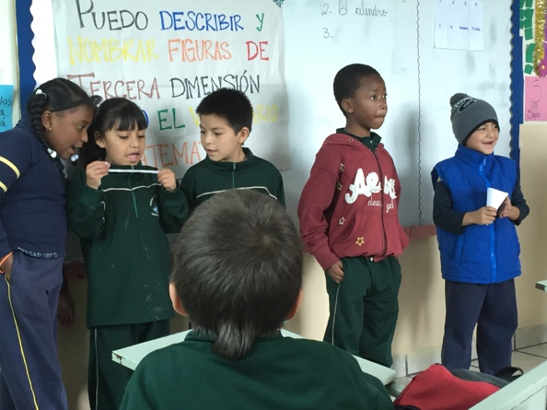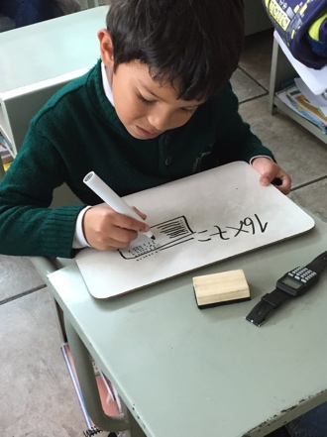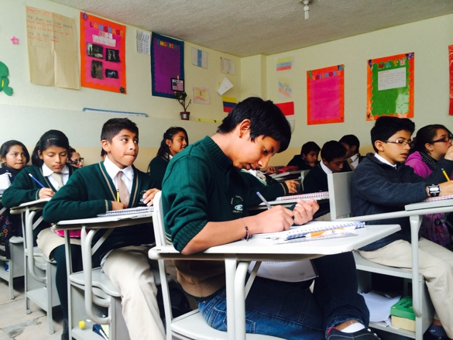

There are a limited number of stipends available to K - 12 classroom teachers for support (fee for conference registration, travel, housing, and incidentals) through the NSF-funded Arizona Master Teachers of Mathematics program, administered by the Department of Mathematics at the University of Arizona.

#### TODOS 2016 Conference is co-sponsored by NSF-funded

#### Arizona Master Teachers of Mathematics (AZ-MTM), award #1035330

The mission of TODOS is to advocate for equity and high quality mathematics education for all students – in particular, Latina/o students.

Participants will leave with important tools, strategies, ideas, and models for their own settings so they can advocate for and enact mathematics teaching that increases Equity, Access, and Achievement for ALL students through rigorous and coherent mathematics!

June 23-25, 2016

Phoenix Metro Area

### **Teacher Stipends**

### [**Apply Now!**](https://toma.memberclicks.net/index.php?option=com_mc&view=mc&mcid=form_207688)

# Attend a mathematics conference like no other!

Ensuring Equity and Excellence in Mathematics for ALL

TODOS 2016 Conference

## Implementing Rigorous Mathematics Standard-Based Curriculum

## Assessing Students’ Mathematical Thinking through Formative Assessment

## Developing Leaders to Achieve Equity and Excellence in Mathematics.

# Key Topics

###### Sessions will focus on the theme

###### Ensuring Equity and Excellence in Mathematics for ALL

## Integrating Language, Literacy, and Culture in Mathematics

## Building on Student, Family, and Community Strengths

## Framing Mathematics Education through the Lens of Social Justice